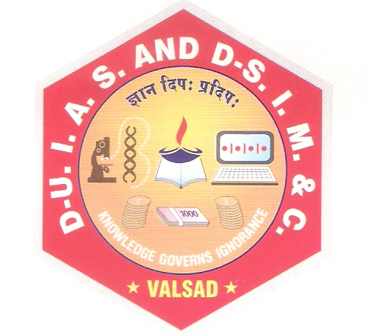
Computer Department

CERTIFICATE

This is to certify that the minor project work is satisfactorily carried out on ___________Graduate Admission Prediction System________ is a work done by Mr. Pathan Shahil Sarfaraz and Mr. Malek Mubin Yasin in partial fulfillment of the requirement for the award of the degree of bachelor of computer applications during the academic year 2025-2026.
I appreciate his / her hard work, honesty and discipline during the training for concerned project in our organization. The minor project work was carried out under our supervision and guidance of internal guide.

__________________ ___________________
Dr. Darshna Rajput Dr. Snehal Joshi
Project Internal Guide I/C Principal

Minor Project Certified Date : _____________
At T.Y.B.C.A (Sem -VI) Examination
Examiners:
1. ________________
2. ________________

